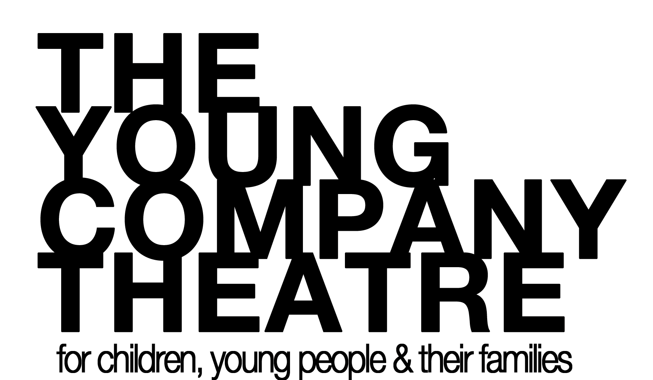
YOUR’VE BEEN INVITED TO APPLY FOR….
The young company THEATRE
CREATIVE PATHWAYS PROGRAM

INTERNSHIP APPLICATION FOR 2018
DUE 15 DEC 2017

The Young Company’s 2018 Young Intern Program is designed to assist regionally based gifted and talented young people to develop the tools needed to move forward with their artistic endeavor within a professional team environment through training, interning and production, whilst celebrating leadership and excellence in our regions young and emerging artists. The Young Company offers up to 14 TYC students aged 10yrs+ the opportunity to complete a cadetship, internship or mentorship in a specific area of the company for those who are committed to investigating the performing arts industry as their vocation; including those investigating performance, directing, playwriting, design and administration/management.

Students can apply to the program by completing the Application Form and sending the completed form to The Young Company, PO Box 8040, Cairns, QLD 4870 or emailing it through to admin@theyoungcompany.com.au Applicants will then be invited to participate in an interview process. Applicants will be notified by the end of January 2018.
We receive many more applications for our Creative Pathways Program than we are able to accept each year so we encourage students to apply each year and continue to participate in their workshop programs and additional TYC Community Programs in order to increase their skills and knowledge and work readiness.

Our Creative Pathways Program allows students to experience the inner workings of a youth theatre company from every angle. It fosters the development of young and emerging arts practitioners, and also facilitates the learning of a range of skills in communication, research, management, problem solving, teamwork, and independent critical thinking. Participants will also have the opportunity to:

- Develop their knowledge and skills in Drama Education.
- Explore the conventions of theatre for children and youth theatre.
- Explore theatre direction skills and techniques.
- Learn the technical aspects of sound application.
- Learn the technical aspects of lighting design and programming.
- Learn the technical aspects of cinematic effects.
- Explore playwriting for children and youth theatre productions.
- Develop knowledge and skills in project co-ordination
- Develop work ready skills for the workforce
- Meet deadlines and work within a team environment.
- Understand Occupational Health and Safety policies

APPLICATION FORM CREATIVE PATHWAYS PROGRAM

Applicant Information
Last Name |  |  |  |  |  | First |  |  |  |  | Date of Birth |  |  | dd/mm/yy
Street Address |  |  |  |  |  |  |  |  |  |  | Apartment/Unit #
City |  |  |  |  |  | State |  |  |  |  | POST
Phone |  |  |  |  |  | Personal E-mail

Emergency contact
Name |  |  |  |  |  |  |  | Relationship
Phone: |  |  |  |  | E-mail Address

Education
School |  |  |  |  |  |  |  |  |  | Grade in 2018
Extra Curricular Activities

Unavailability
Please provide us with any known dates that you will be away.
Date/s
Date/s
Date/s

More about you
What is your previous/ current experience at TYC (Student)?
Please note, you must be a TYC student to participate in the internship program.
What is your previous experience at TYC (Intern)?
What are you hoping to gain from this internship?
Is there anything else you would like us to know about you?

DECLARATION I declare that the information provided in this application is true and accurate.

Student Full Name: __________________________________________________
Signature: __________________________________________________
Date: __________________________________________________

Parent Full Name: __________________________________________________
Signature: __________________________________________________
Date: __________________________________________________

AVAILABILITY
At The Young Company, we require interns to complete a set amount of hours to complete their Internship. You must complete a minimum of 70 hours throughout your Internship. This will be made up of your attendance in the class you Intern, helping out with TYC parties and our TYC Short Cuts and TYC CRUNCH festivals. Please indicate on the grid below which classes you would be interested in Interning. If you are wanting to do more than one class please preference each class with a number, one being the class you most want to Intern. PLEASE NOTE: due to scheduling it may not be possible to satisfy everyone’s preferences.
